May 31, 2016

Av-Tech Industries - A Division of Fastenal Company
1100 Corporate Drive West,
Arlington, TX, 76006, United States

Dear Mr. Dover,

As the management official of Systems and Services Certification, a Division of SGS North America, Inc., we hereby acknowledge that:

- Only parts for which documentation is on file at Av-Tech Industries - A Division of Fastenal Company, as delineated in AC 00-56B, Appendix 1, will be sold for installation on civil aviation products.

- Systems and Services Certification, a Division of SGS North America, Inc. has completed an audit and found your quality system to be in compliance with the provisions of AC 00-56B and FAA-AC-0056 on (Date of audit)

- A copy of the audit result is on file and available for inspection by any interested person.

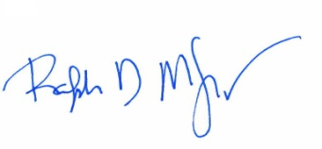
Ralph McLouth May 31, 2016
Vice President of Accreditation, North America

NOTE: This letter shall be accompanied by a copy of the signed quality system certificate.

