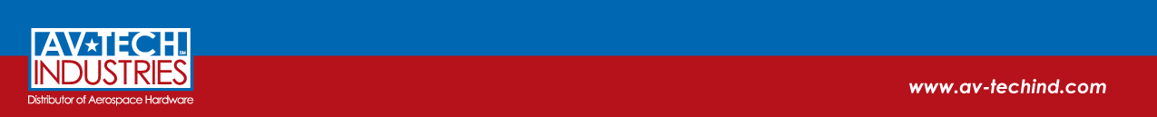
Av-Tech Industries – Division of Fastenal
Certifying Body - SGS North America, Inc Cert# US16/842689
- AS9120 Revision A Certified
- ISO9001:2008 Certified
- FAA-AC-0056 Certified
- Cert Expiration: 15 September 2018
General:
- Sourcing and distribution of Fasteners and Components for application in Aviation, Space, Defense, and Commercial Industries
- Self-Release supplier for Honeywell International
- Delegated Supplier Partner with Sargent Controls and United Launch Alliance
- Approved supplier for Lockheed Martin Space Systems, Lockheed Martin Fire and Missile, Honeywell International, Sargent Controls, United Launch Alliance, Aerojet, Celestica, Curtiss-Wright, Textron, Triumph Group, Northrop Grumman, Raytheon, Thomson Aerospace and Defense (Meggitt), Macro Industries, and SESI
- Over 25 years of industry experience on-site
- Authorized Distributor for various major industry OCM/OEMS
Capabilities:
- Inspection equipment calibrated in accordance with ISO10012-1 & ISO/IEC 17025:2005
- Gage inventory includes, but not limited to the following: Adjustable Thread Rings, Plug Gages, Calipers, Johnson Gage Threaded Segments, Micrometers, Pin Gages, Optical Comparator, and Boroscope
- Form, Fit, and Function inspections upon receipt of all Mil-Spec hardware to NAS, MS, AN standards, customer specific drawings, and third party testing verification upon request
- First Article Inspection capabilities, when required, per AS9102
- Ability to upload documentation to customer specific interfaces or email groups
- Ability to navigate customer specific interfaces such as: ESIS HOM, Honeywell HASP, Exostar, Workgroup Collaboration, Intelligent Data Management, Supplier Data Transmittal, SCATS, Approved Source Lists, DexCenter, NetInspect, EDSS Sharepoint
- On-site packaging of hardware in accordance with customer requirements
- Custom kitting capabilities – Modular At-A-Glance Kitting concepts – Support kitting for Space, Aviation, and Defense applications (Global Positioning Satellites, Atlas/Delta, Booster Kits, MRAP, C-130 Armor Kits, Sikorsky Helicopter)
- Kitting projects for Northrop Grumman, Lockheed Martin Space Systems, United Launch Alliance, Macro Industries, Arista Aviation, and SESI
- Delegates secondary operations in accordance with customer authorization and declaration of requirements and customer approved source list that mandates who is approved to perform secondary sub-tier processing (we do not possess any manufacturing capabilities nor do we consult)
- Document retention of 15 years minimum, unless otherwise stated in customer specific terms and conditions

