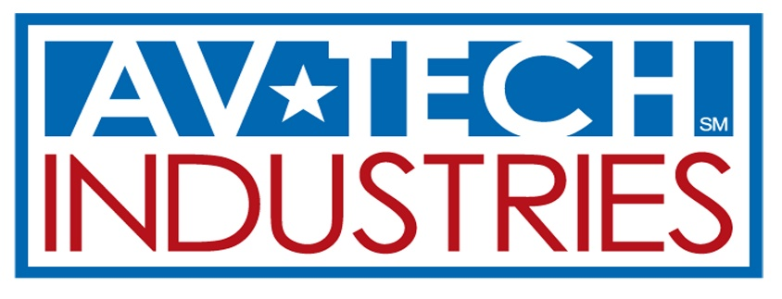

Division of

Conflict Minerals Statement

Av-Tech Industries is fully committed to the responsible sourcing of “Conflict Minerals” (tin, tantalum, tungsten and gold) from the Democratic Republic of the Congo (“DRC”) and adjoining countries. The concern that profits from the sale of certain minerals from the DRC Region may be financing armed groups that are engaged in civil war and are committing human rights violations. In accordance with provisions of the Dodd-Frank Wall Street Reform and Consumer Protection Act of 2010, the U.S. Securities and Exchange Commission (“SEC”) has adopted rules that require public companies to provide certain disclosure if any products they manufacture or contract to manufacture contain “Conflict Minerals” that are necessary to the functionality or production of those products. Av-Tech Industries fully supports the objectives of the SEC’s rules and will perform all necessary due diligence in order to avoid the use of tin, tantalum, tungsten and gold that have funded armed groups in the DRC Region to further the goal of ending the human rights violations in the region.

Av-Tech Industries does not knowingly procure any of the specified metals from the DRC Region unless they originate from mines or smelters that are certified as “Conflict Free”. Av-Tech Industries will conduct due diligence, through use of the Electronic Industry Citizenship Coalition (EICC) and the Global e-Sustainability Initiative (GeSI) template, and request that our suppliers undertake reasonable due diligence with their supply chain or manufacturers to ensure that specified metals are not being sourced from conflict mines in the DRC Region.

Av-Tech Industries Policy

Av-Tech Industries fully supports the objectives of the U.S. Legislation and SEC rules on the supply of “Conflict Minerals”.

Av-Tech Industries will not knowingly procure or supply products or materials that contain tin, tantalum, tungsten and gold that fund conflict in the DRC Region.

Require our suppliers to undertake reasonable due diligence to determine that they are acquiring tin, tantalum, tungsten and gold from sources that will certify that the metals are “Conflict Free”.

Expect our suppliers to provide documentation stating that the materials used in the production of our products supplied to us are “Conflict Free”.

Av-Tech Industries Supplier Expectations:

Request that our supply base complete surveys, utilizing the EICC/GeSI template, regarding the country of origin of any conflict minerals contained in such products or components.

Expect that our suppliers adopt a policy regarding conflict minerals that facilitates compliance with Av-Tech Industries as well as expect their supply base to do the same.

Require that all suppliers agree to cooperate with Av-Tech Industries in connection with any due diligence that Av-Tech Industries chooses to perform with respect to its country of origin inquiries.

When necessary, require a supplier to provide reasonable proof of the due diligence performed by the supplier to support the country of origin certification provided to Av-Tech Industries.

If for any reason we discover that tin, tantalum, tungsten or gold were procured by us was produced in the Conflict Region, Av-tech Industries will take appropriate actions to transition the product to Conflict Free sources.

